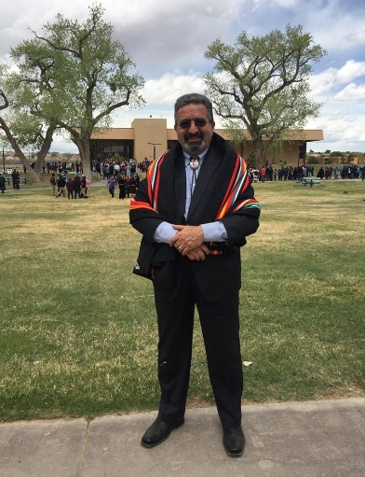Dr. Vadiee, the outreach lead for the TECHLAV project, has been honored as the American Indian College Fund's 2016 Faculty of the Year! He was robed by the acting director of the Bureau of Indian Education, Ms. Ann Marie Bledsoe Downes.

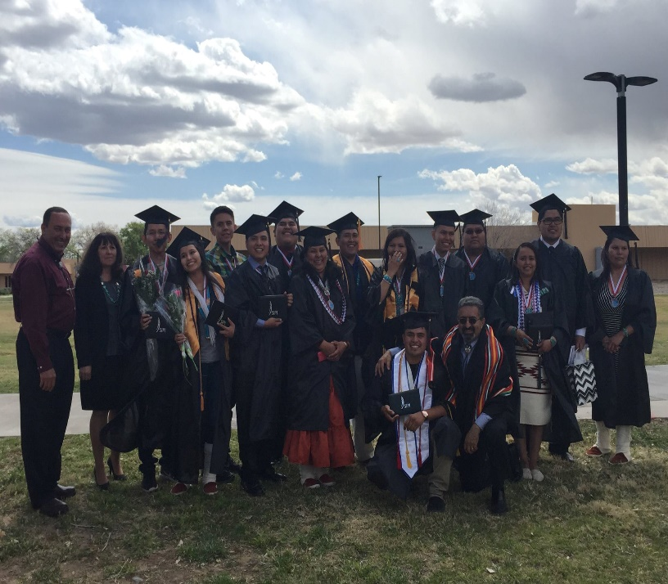SIPI’s engineering programs graduating class of 2016! The largest Pre-engineering graduating class in the history of the Tribal Colleges! SIPI has the largest engineering and engineering technology program among the tribal colleges. 80 students strong and counting!